


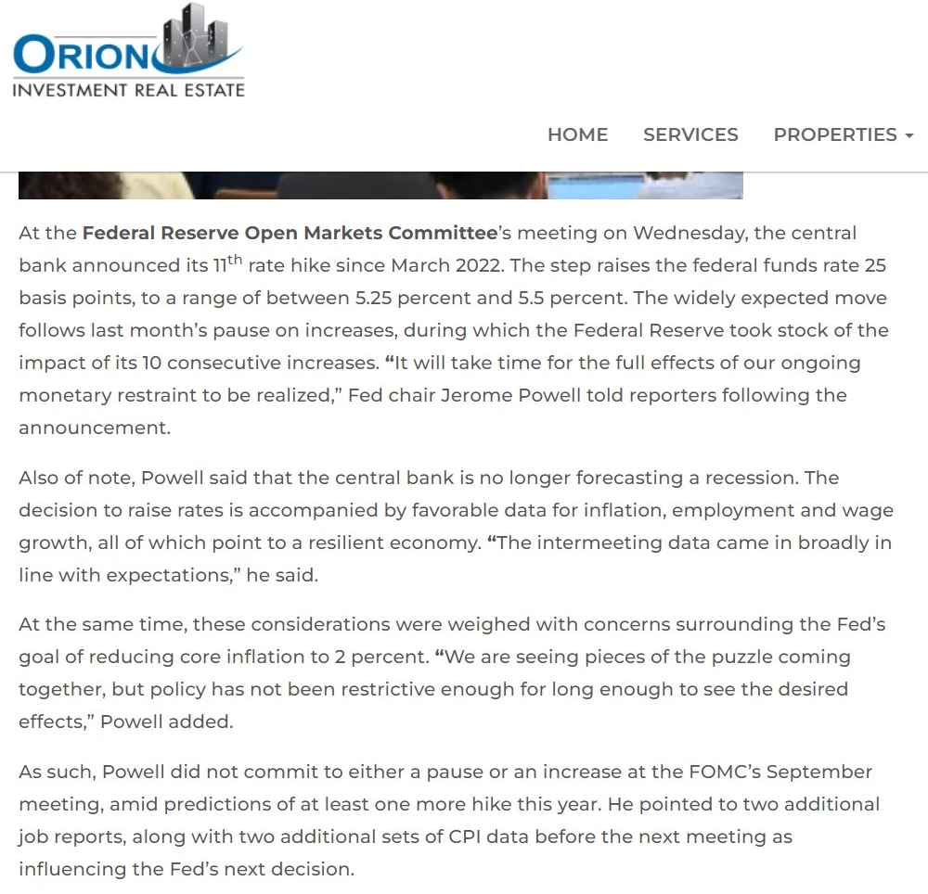

RATES
INFLATION
RECESSION
STOCK MARKET
REAL ESTATE MARKET
FEAR




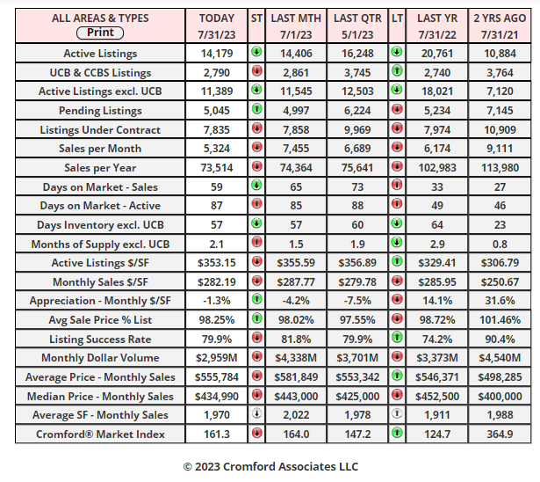


Jul 29 - The re-sale housing market has lost a bit of steam over the last 2 months and is now plodding along without excitement and missing a large percentage of its usual volume.
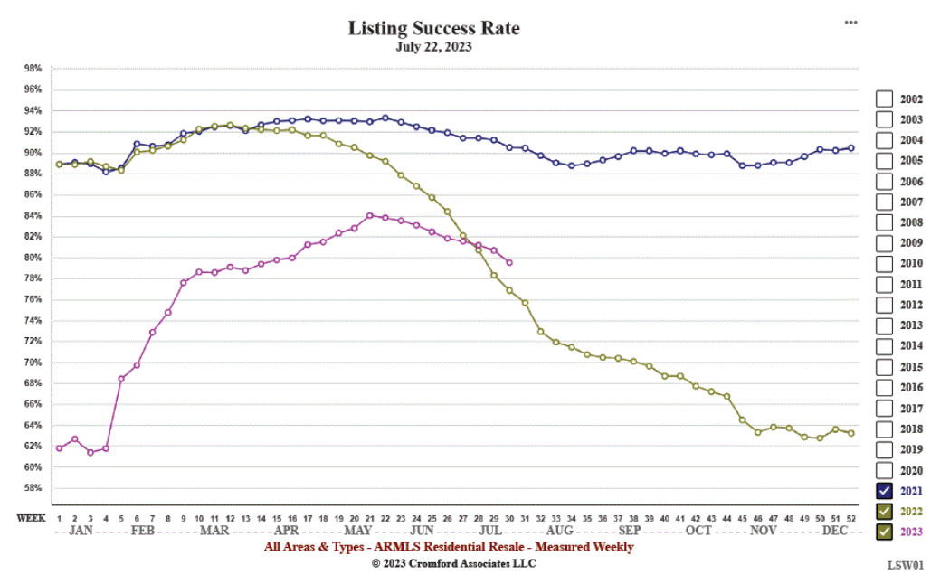
While prices remain on an increasing trend, the listing success rate has been falling for 9 weeks and is now under 80% for the first time since April.
The high 70s is still well above average (mid 60s), but the trend is not a good one for sellers or their agents.
Jul 27 - Here is our latest table of Cromford® Market Index values for the single-family markets in the 17 largest cities

The market continues to slowly lose steam and the average CMI change in these 17 cities over the last month was -5.9%, more negative than last week when we measured -5.3%
Only 5 cities continue to show a positive change from this time last month, while 12 show a negative trend for sellers, particularly Tempe, Fountain Hills, Avondale, Glendale and Peoria.
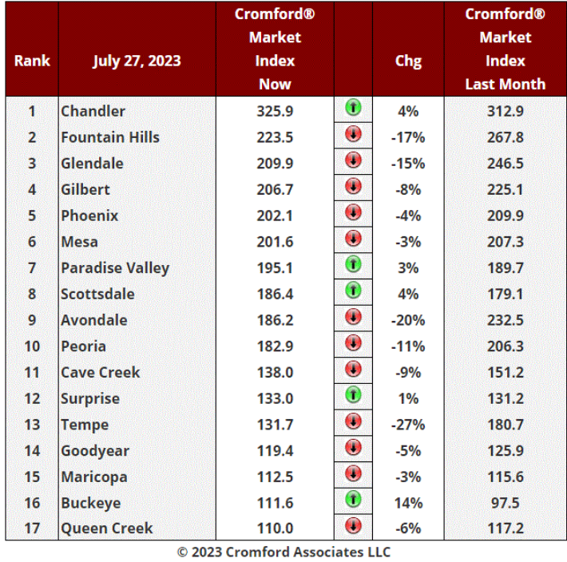
Buckeye is the highlight and has overtaken Queen Creek which slips into last place.
Mortgage rates jumped back over 7% today and both sellers and buyers in the re-sale market find this depressing. Our CMI represents the data in the MLS which is largely comprised of re-sale listings. The situation in the new home market is quite different, because home builders do not suffer a lack of motivation. For new homes, volumes are quite good, despite the high interest rates. Prices are also on the rise. Buyers of new homes appear to retain a strong will to buy and homebuilders' finances look stronger than they have for many years. This is reflected in their stock prices which in many cases are hitting new all-time highs this month. Some examples:
- Lennar Corporation (LEN) - $125.82 - all-time high was $133.24 on July 14
- D R Horton (DHI) - $127.05 - all-time high was $132.30 on July 25
- Meritage Homes Corporation (MTH) - $138.40 - all-time high was $148.74 on July 18
- KB Home (KBH) - $53.05 - - all-time high was $55.37 on July 19
- Pulte Group Inc (PHM) - $83.64 - all-time high was $86.01 on July 27
The builders are loving the fact that supply is so weak in the competing re-sale sector. This is the opposite of where they were in 2009 when they had to cope with a flood of bank-owned and short-sale homes at rock-bottom prices. This made new-homes look very expensive, especially as re-sale homes were changing hands for less than their rebuild-cost.
Jul 24 - The monthly average price per square foot for closed listings has dropped over the last 4 weeks - see the chart below:

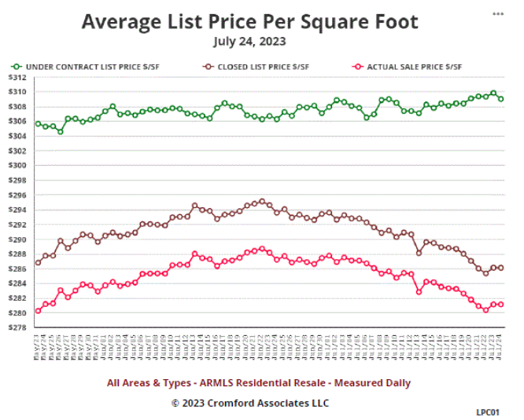
Is this a worrying sign of weakness? Not really. It is a seasonal effect caused by the relative absence of luxury property closings during the third quarter. It happens almost every year. Luxury closings peak in May and June and after that, people who can afford luxury homes usually find ways of not being in Central Arizona in July and August, when temperatures tend to stay over 110F for long periods of time. They don't like moving in during that weather. Homes that close during July and August tend to be smaller and cheaper, designed for regular folks, who have to put up with the heat.
Two things in this chart that are sending positive signals:
- The average price per square foot for listings under contract is still showing a rising trend, albeit a slow one.
- The average % of list for closed listings is climbing - you can see that the red and brown lines are getting closer over time.
The Cromford® Market Index is still telling us we have a seller's market at 160-165, even though it is no longer moving higher.
The high 70s is still well above average (mid 60s), but the trend is not a good one for sellers or their agents.

