





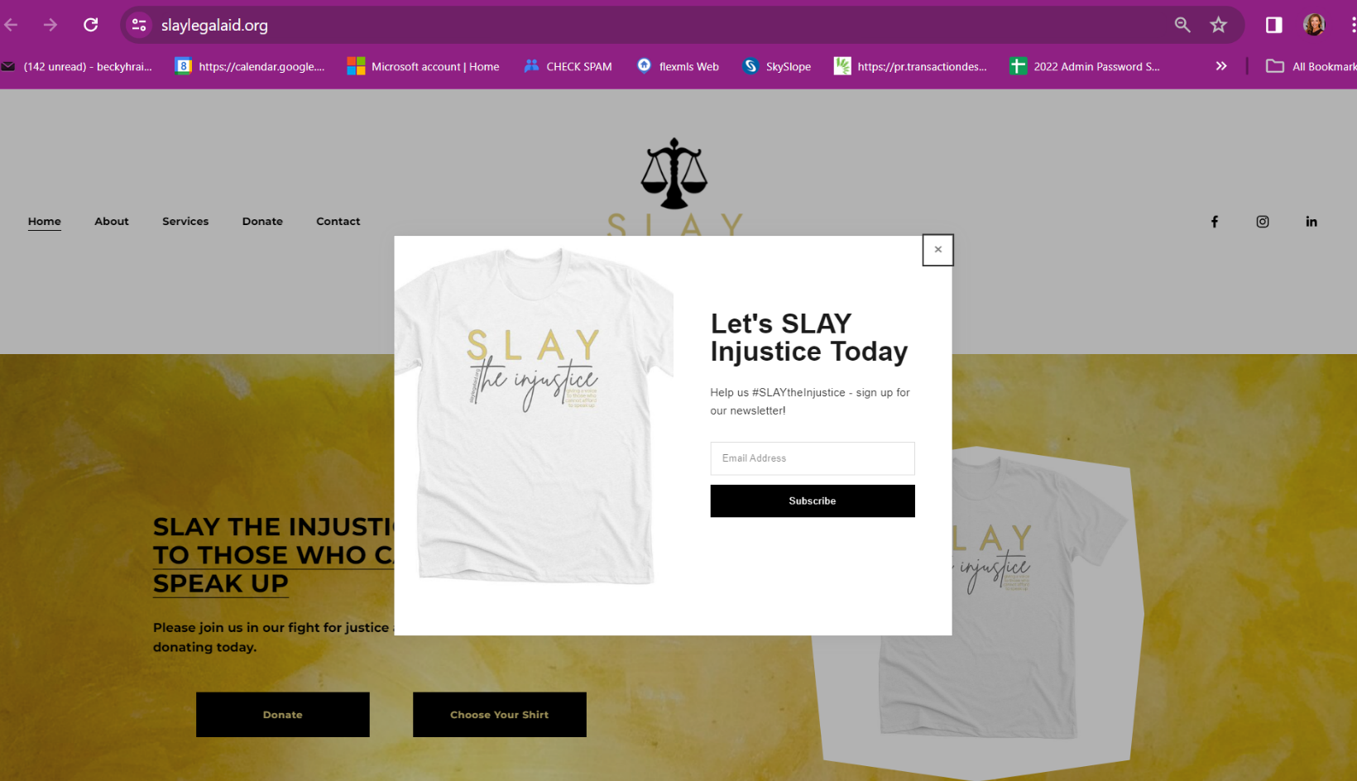
- Love & Relationships, Gene Keys, Breathwork, Spirituality, Metaphysics, NFL, Inspiration, Motivation
Bret Lockett is an internationally recognized speaker, love and relationship expert, and former NFL star who helps both men and women find love and intimacy in their lives. He is known for his deep understanding of the conscious collective and for his efforts to balance the yin and yang energies in relationships.
Bret's expertise in Gene Keys is a pivotal part of his transformative approach to coaching, which combines breathwork, diaphragmatic breathing, and other modalities to help people deal with emotional and physical trauma. His personal experiences, including his time as an NFL player, have inspired him to develop a unique method that has empowered thousands of individuals worldwide to experience deep healing and breakthroughs in their lives.
In addition to coaching, Bret also serves as a board advisor for The Flow Research Collective, an esteemed organization led by best-selling author Steven Kotler. Alongside esteemed individuals like Dr. Andrew Huberman and Dr. Michael Gervais, Bret contributes to groundbreaking research and guides individuals in unlocking their highest potential. Driven by love and kindness, Bret is committed to transforming lives, promoting overall well-being, and empowering individuals and organizations to unlock their true potential in love and relationships.

https://linktr.ee/Bretlockett

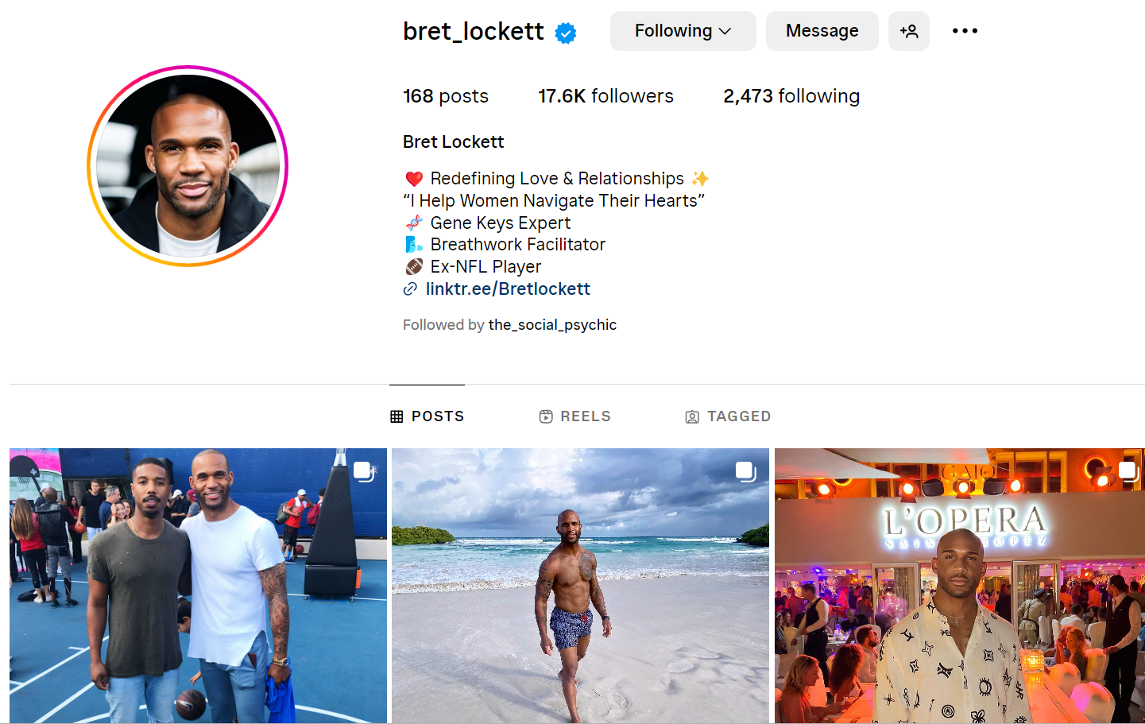
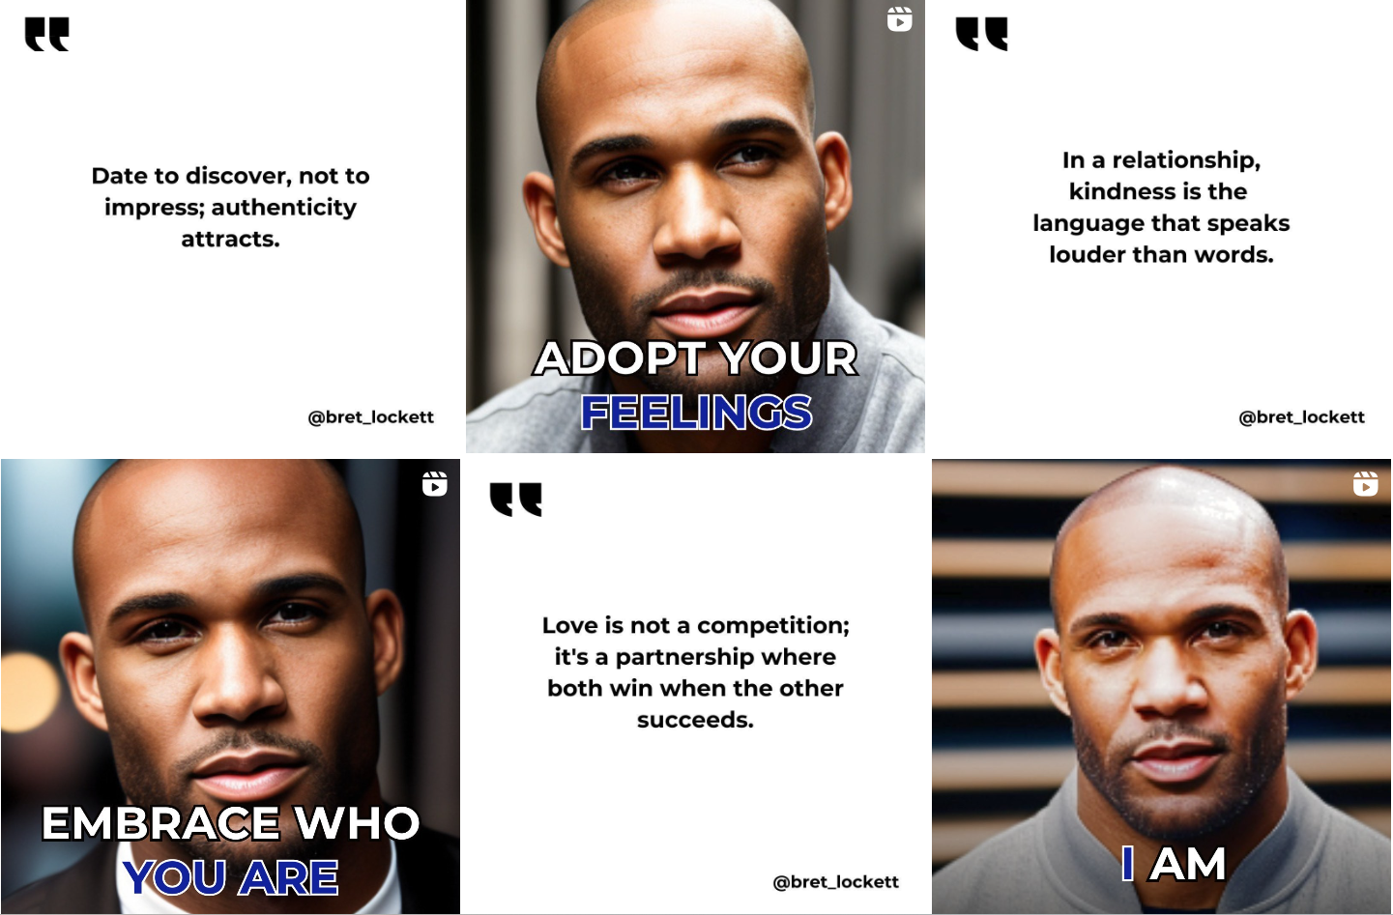

https://genekeys.com/golden-path/
https://genekeys.com/c/new/
https://apps.apple.com/us/app/triple-flame/id6448287073?ign-itscg=30200&ign-itsct=apps_box_link

